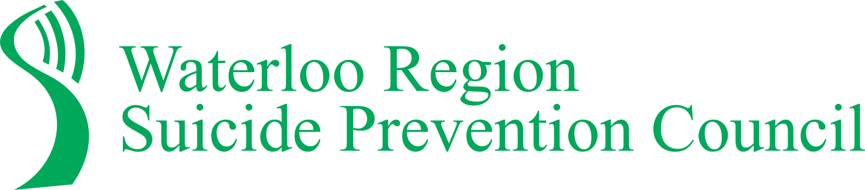
Our Mission
Our mission is to reduce suicidal behavior and its impact on individuals, families and communities. We believe that every person has the right to be supported in living a healthy positive life.
Our Vision
Our vision is to build a suicide safer community by applying a strengths-based approach focusing on wellbeing and resiliency. We believe the voices of those with lived experience of suicide are crucial to increasing understanding of suicide and effective suicide prevention responses. The Waterloo Region Suicide Prevention Council engages individuals, families and organizations to increase their participation in suicide prevention, intervention and postvention – hope, help, and healing – focusing on the following four key pillars.
#2-Partnership and Capacity Building
Waterloo Region Suicide Prevention Council engages and works in partnership with individuals and organizations across sectors to help them
understand their role in suicide prevention and
identify ways they can
implement changes
that will be sustainable.
WRSPC strives to increase
community capacity to
address suicide related
issues.
#1- Community Awareness
Waterloo Region Suicide Prevention Council increases public awareness that suicide is a significant and shared health problem in
our community using many
platforms including media,
social media and events.
WRSPC believes that
Suicide is everybody’s
responsibility and is
preventable through
community engagement
and action.

#3- Training and Education
Waterloo Region Suicide Prevention
Council works with the community to
respond to the risk factors of suicide by
providing educational resources and delivering
impactful and effective suicide awareness and intervention workshops, conferences and presentations.
#4- Research and Evaluation
Waterloo Region Suicide Prevention
Council collaborates with community
partners to collect statistical data on
suicidal behaviour in order to examine and analyze trends, and identify priorities for community action. WRSPC also monitors its outreach programs and interventions to evaluate their effectiveness.

